|  |  |  |
| --- | --- | --- |
| **Avon High School** | **ACE COLLEGE ALGEBRA II - NOTES** | **Mr. Record: Room ALC-129** |
| Section: 9.5 | Determinants and Cramer’s Rule | Semester 2 - Day 18 |

**The Determinant of a 2 x 2 Matrix**

**Definition of the Determinant a 2 x 2 Matrix**

The determinant of the matrix  is denoted by  and is defined by



We can also say that the **value** of the **second-order determinant**  is .

**The Multiplicative Inverse of a Matrix**

**Example 1**

**Evaluating the Determinant of a 2 x 2 Matrix**

**Example 1**

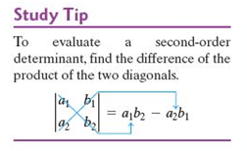 Evaluate the determinant of each of the following matrices:  **a.  b. **

**Solving Systems of Linear Equations in Two Variables Using Determinants**

**Cramer’s Rule**

If 

then  and 

where 

**Why Does Cramer’s Rule Work?**

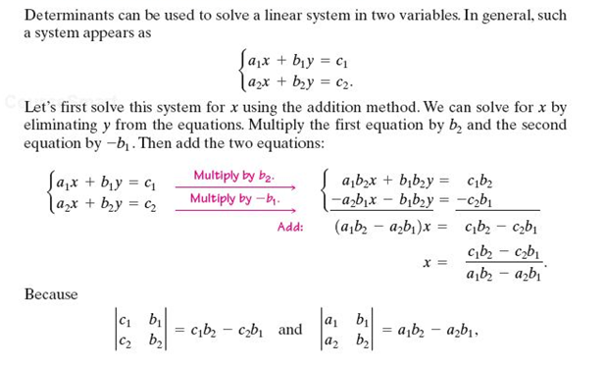

**Using Cramer’s Rule to Solve a Linear System**

**Example 2**

Use Cramer’s Rule to solve the system:



**The Determinant of a 3 x 3 Matrix**

**Definition of a Third-Order Determinant**



**I would not recommend memorizing the above definition.**

**Instead use the idea in the box below.**

**Definition of the Determinant of a 3 x 3 System**

A third-order determinant is defined by



**Evaluating the Determinant of a 3 x 3 System**

**1.** Each of the three terms in the definition contains two factors – a numerical

factor and a second-order determinant.

**2.** The numerical factor in each term is an element from the first column of the

third-order determinant.

**3.** The minus sign precedes the second term.

**4.** The second-order determinant that appears in each term is obtained by

crossing out the row and the column containing the numerical factor.



**Evaluating the Determinant of a 3 x 3 Matrix**

**Example 3**

Evaluate the determinant of each of the following matrices:  

**Evaluating the Determinant of a 3 x 3 Matrix**

**Example 4**

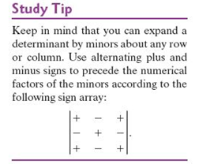 Evaluate the determinant of each of the following matrices:  

**Solving Three Equations in Three Variables Using Determinants**

**Cramer’s Rule**

If 

then 

where



**Using Cramer’s Rule to Solve a Linear System in Three Variables**

**Example 5**

Use Cramer’s Rule to solve the system:



**Cramer’s Rule with Inconsistent and Dependent Systems**

**Determinants: Inconsistent and Dependent Systems**

**1.** If  and at least one of the determinants in the numerator is not 0, then

the system is inconsistent and has NO SOLUTION.

**2.**  If  and all of the determinants in the numerator is 0, then the

equations in the system are dependent. The system has INFINITELY

MANY SOLUTIONS.